FELL DETECTION

CS328 – Group 7 Final Project

Weihai Chen, Xinyong Qiu, Che-Wei Lin

What the app is supposed to do…

The app detects falling from the users and follow up with responses: Immediately open a new popup window and the user have 15 seconds to press the “I’m fine” button or “I need help!” button. At this point, the phone will vibrate and play the ringtone (depend on user’s preference) to get attention for help in case of a serious fall. After 15 seconds or user has pressed “I need help!” button, the phone will call the designated phone number inputted by the user.

Data Collection

Activities involved in collection: walking, jogging, jumping, stationary, falling, sitting down, dropping phone, squatting

Each activity was collected for 5 minutes instead of **falling**. For falling, we followed the procedure like so: Start collecting labeled data, fall, stop collecting, get up, and start collecting again. We did this for 40 falls.

Data Accuracy

Most of the classifier weren’t having a good result as compare to Random Forest Classifier with ~95% accuracy most of the time.

-screenshot matrix some other classifier-

-screenshot accuracy of other classifier-

-screenshot matrix of random forest-

-screenshot accuracy of random forest-

What The App Looks Like

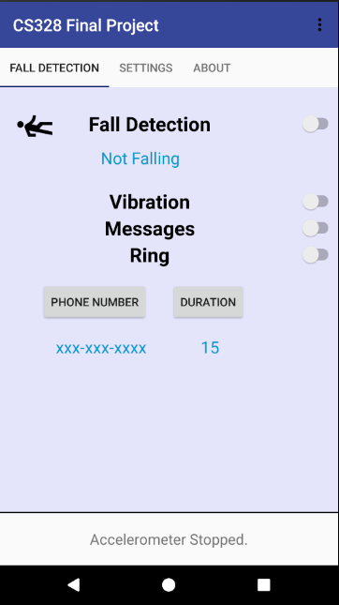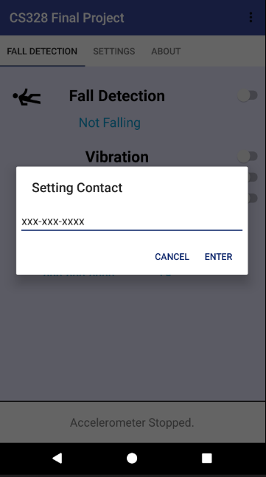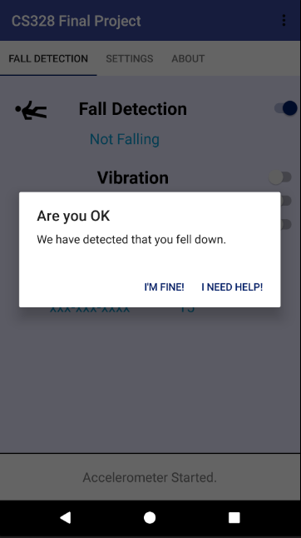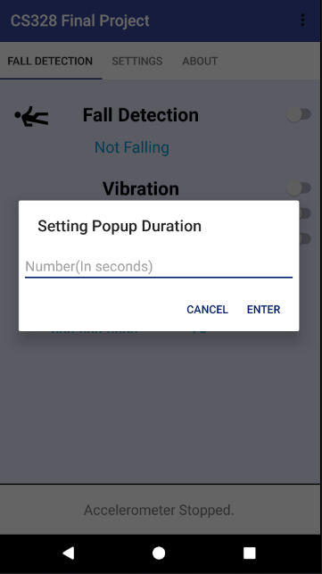

Future Possible Improvements

1. Better UI design and implementation
2. Train even more activities
3. Might be able to try it on wristband
4. More features like Tilt Angle for better accuracy
5. WakeLock and disable KeyGuard for locked phones